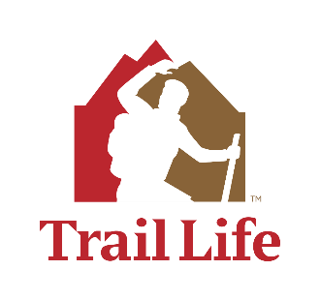**OH-0414’s Invitational Rocket Race 2024**

Saturday May 4th, 1:00-5:00pm

Hosted by Trail Life Troop OH-0414

745 Symmes Rd, Fairfield OH 45014

OH-0414 will once again be hosting our annual Rocket Race as an invitational event this year. For those new to this event, Trailmen will build paper rockets during the first 30 minutes of the event. After that Trailmen will be divided into preselected patrols to participate in several stations along with the rocket launching competition. The various stations will teach and reinforce Science/Technology and TrailLife skills. This is an all-ages event as the rockets are powered by Trailmen jumping on 2-liter bottles to send the rockets down range. This year the theme for the event will be “Using the Forces”.

Cost is $5 per Trailman and is due as part of the registration. Checks should be made payable to “Trail Life Troop OH-0414”. Registration Form and Payment should be sent to:

**Rocket Race**

**C/O Trail Life Troop OH-0414**

**745 Symmes Rd**

**Fairfield OH, 45014**

Because of time and space limitations we are planning to limit the event to 60 Trailmen. This means you need to get your registration in early if you want to ensure you troop has their spots reserved. Troops should provide enough registered adults to maintain proper ratios based on the contingency attending from their troop. Anticipate at least some of these individuals will need to assist with activities during the event.

Check-in will open at 12:45 with the rocket building session from 1:00 – 1:30

Registration Closes April 6th.

OH-0414’s Invitational Rocket Race 2024

Registration Form

Troop Number: ____________

Phone: ______________________ E-mail: _________________________________________

Designated Leader for Event: __________________________

|  |  |  |  |  |  |  |
| --- | --- | --- | --- | --- | --- | --- |
| No. | Trailman Name | Level | | | | |
| Fox | Hawk | Mt Lion | Nav | Adv |
| 1 |  |  |  |  |  |  |
| 2 |  |  |  |  |  |  |
| 3 |  |  |  |  |  |  |
| 4 |  |  |  |  |  |  |
| 5 |  |  |  |  |  |  |
| 6 |  |  |  |  |  |  |
| 7 |  |  |  |  |  |  |
| 8 |  |  |  |  |  |  |
| 9 |  |  |  |  |  |  |
| 10 |  |  |  |  |  |  |
| 11 |  |  |  |  |  |  |
| 12 |  |  |  |  |  |  |
| 13 |  |  |  |  |  |  |
| 14 |  |  |  |  |  |  |
| 15 |  |  |  |  |  |  |

Total Number of Youth Trailmen attending: ___________

Cost per Trailman: X $5.00

Total Payment: ___________

Number of Registered Adults Attending: ___________

Troop Ministry Liaison Signature Approval

Signature: _______________________________________ Date: _________________

Print: _____________________________________